

DBE SERVICES
ONLINE PORTAL

Please see your email for your link, username and password to gain access to your schools’ portal system. Please write them into this document for future reference.
This contains all the documents and certificates that you may need, it also has a calendar of
servicing works that have been done and are due.
All servicing on your calendar is dated the 1st of each month which means that the contractor is
needed to go to your premises that month anytime from the 1st onwards, that isn’t a booked in date. They are required by us to arrange with you and visit you within that month.
It just gives the contractor a start date of what month they are to contact you to arrange to come and
do that service within that month. They will call you to arrange this directly.

To access your schools portal, just click the link below:
https://dbe.tabsfm.co.uk/IntranetMobile/

Just copy and paste the username and password from the below as its case and space sensitive.
Username: (Please add your username here for reference)

Add the password as below and that should log you into your portal.
Password: (Please add your password here for reference)

You can change the password to something more memorable if needs be once logged in.
Make sure to pass this info onto any other staff that also use the portal system.
I’ve also attached the school portal guide in case you don’t have a copy for instructions of how
to use the portal.

Email: invoices@dbeservices.co.uk
Phone: 01254 958850

CONTENTS
- ACCESSING THE SYSTEM 1
  - Accessing and logging in to the Online System 1
  - Changing your password 2
  - The Home Page 3
- USING THE SYSTEM 4
- REACTIVE MAINTENANCE TAB 4
  - Requesting a Job 5
  - Searching Jobs 7
  - PPM Reports (This section has been removed, see section 3) 9
  - Maintenance Requests 9
  - Works Diary 11
  - Year Planner 13
- ACCESSING YOUR DOCUMENTS 15
- LOGGING OFF THE SYSTEM 16

ACCESSING THE SYSTEM

Accessing and logging in to the Online System
Open up an internet page and type in the following into the internet address bar: https://dbe.tabsfm.co.uk/IntranetMobile/
You will be greeted with this login page to the system. Your username and password will have been emailed over.
If you need this resending at any point please contact the office; 01254 958850 or invoices@dbeservices.co.uk
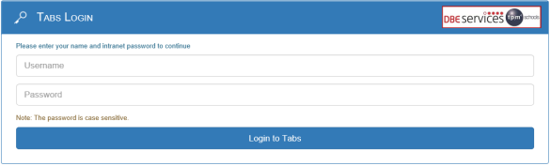

Input your username and password provided and click ‘log in’. Please note that this is case and space sensitive.

Changing your password
When logging on for the first time the system will present you with the option to change the password straight away, it is recommended you do this.
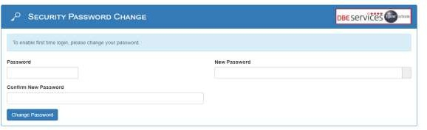

The password can be changed at any point using the User Admin tab on the top righthand corner:
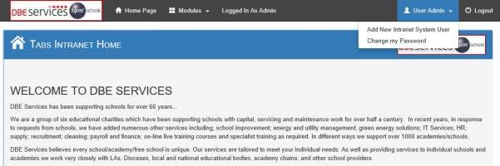

To change password please click on the ‘change my password’ option and follow the instructions.

For any forgotten passwords please contact the office and this can be reset.

The Home Page
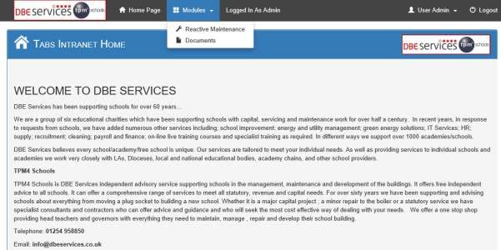
The system Home Page is set out below, all the information on the system will be accessed via the Modules tab on the top bar, when clicking on this it will give you two options: Reactive Maintenance and Documents.
Documents - this tab provides access to all past information from the old portal (copies of historic service sheets, reactive invoices and any other relevant information).

Reactive Maintenance – this tab covers all your planned maintenance, compliance, reactive works and quotation documentation.

Use the Modules or Home Page tabs at any point to navigate back to the different items.

USING THE SYSTEM

Reactive Maintenance Tab
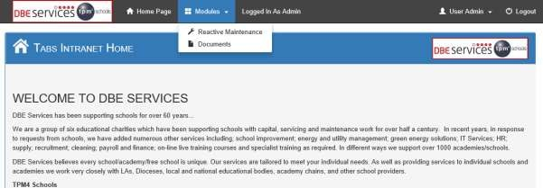

To access this, click on ‘Reactive Maintenance’.

The tab will bring up the following items:
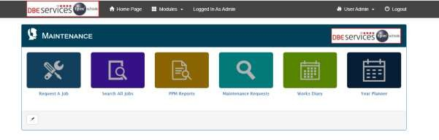





- Request a Job – to request jobs through the system
- Search All Jobs –to search for all jobs on the system (maintenance and reactive jobs). To view service paperwork and reactive invoices.
- PPM Reports – these are not in use and will be removed from the system
- Maintenance Requests – to view the jobs that have been requested on the system
- Works Diary – to view all maintenance and reactive jobs that are planned to take place in the upcoming months. To view service paperwork and reactive invoices.
- Year Planner – to view the annual year planner showing all maintenance and reactive jobs that have been completed during the calendar year and all jobs planned for the remainder of the year. To view service paperwork and reactive invoices.

Note: this system has been in use since September 2020. Previous services prior to this date (PPM Jobs) will be on the system and can be seen with status of ‘Complete – Historic Job’. To find the service sheets/reports relating to these please go to the Documents tab (see section 3)

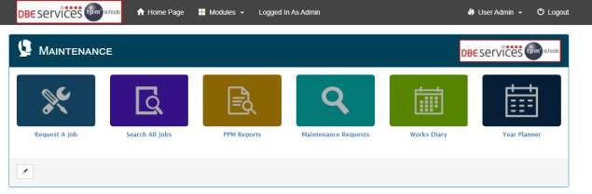
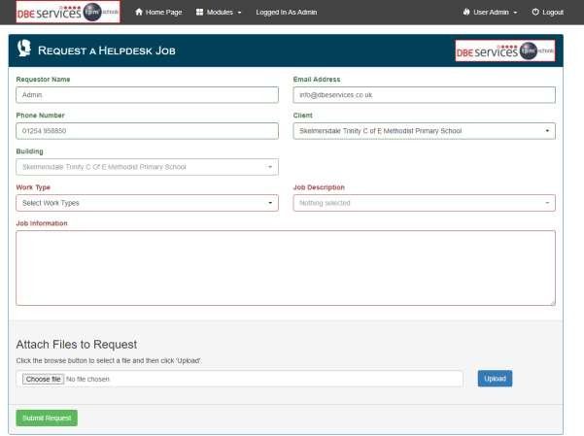
Requesting a Job
This allows the school to log a job request via the system.

Click on ‘Request a Job’.

Fill in the following sections in this order:
    - ‘Work Type’ select from the dropdown list if the request is either a planned maintenance (service request relating to annual service contract), reactive (reactive job request/repairs etc.) or quotation request.
NOTE. Text boxes will appear red to inform you what is missing before allowing you to submit.
    - ‘Job Description’ select from the dropdown list a description of the closest to the job – i.e. ‘Boiler’ for broken boiler. ‘Plumbing’ for leaking toilets etc.

    - ‘Job Information’ is a free type box where specific information on what the job relates to can be added – i.e. boiler number 2 is broken in the technology block. Please add as much information into this as possible such as location details, access times, contact information if different from the main school number/email.

Final Step
If there are any photos or files that will help with this request upload them to this section – choose the file and click on the upload button on the right.
Please click on ‘Submit Request’. Your job will then be sent to the help desk.

Once a job has been raised a Job Request Receipt will be raised to confirm this has been sent:
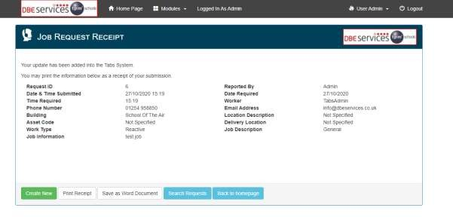

There is the option to save this as a word document if you wish to keep a copy of the receipts on your own system. Otherwise, the system holds a copy of this under ‘Maintenance Reports’ item 2.4.

To see the jobs that have been logged on the system via the ‘Request a Job’ tab please see Maintenance Requests (item 2.4)

Searching Jobs
This allows schools to search for jobs on the system both reactive (help desk jobs) and servicing (PPM jobs/planned maintenance):
Click on ‘Search All Jobs’.

This page will open and will have automatically defaulted to your school (unless you are a diocese or MAT logging on and have access to multiple schools – amend the search accordingly)
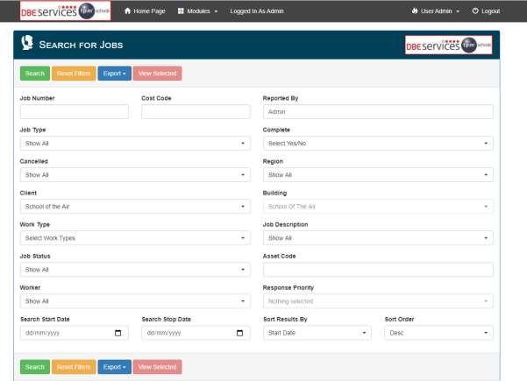
Use the various headings to narrow down the search.
Once you have made the selections you want click on the search button at the bottom or the top of the page.

Use the job status to narrow down where the job/service is up to.
The Job Type will narrow down Help Desk Jobs (reactive job requests) or PPM jobs (service jobs relating to the annual service contract).

Use this if you want to view all completed / incomplete jobs.

If you know the specific job number, you can search this here. E.g. DBES0000.

The items searched for will appear in a list underneath:

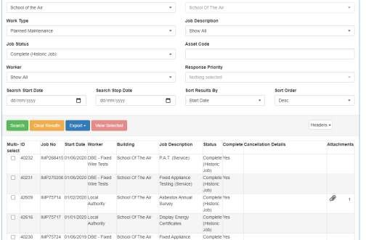

The job number will either PPM… (these relate to services – PPM jobs) or DBES… (these relate to reactive jobs – Help Desk jobs).

Click on any of the items listed and it will open up the job details.
If there are any attachments with the job it will show in this column and have a paperclip next to the job. For planned maintenance (services) this will generally be service sheets/reports. For Reactive (job requests) this will generally be invoices and the work sheets.
Invoices following reactive job requests
To find the jobs that have been invoiced for search on the following:
Job Type – Help Desk Jobs Only
Job Status – Complete – Invoice Received
To find the jobs that have been completed but not yet invoiced for search on the following:
Job Type – Help Desk Jobs Only
Job Status – Complete – Awaiting Invoice
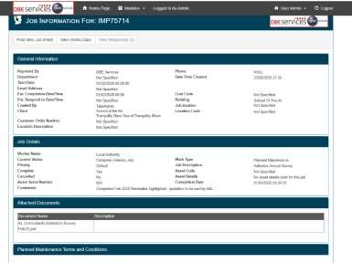

When selecting the particular job to view this screen will appear. If the one selected has an invoice attached this will appear in the attachments section. Click on this to expand the section and the document will be there. Click on the document and this will either open in a new tab/download a copy for you depending on your internet settings.

PPM Reports
This section is to be removed from the portal. (PLEASE SEE SECTION 3)

Maintenance Requests
This enables schools to see what requests have been raised through the system and when they have been implemented.
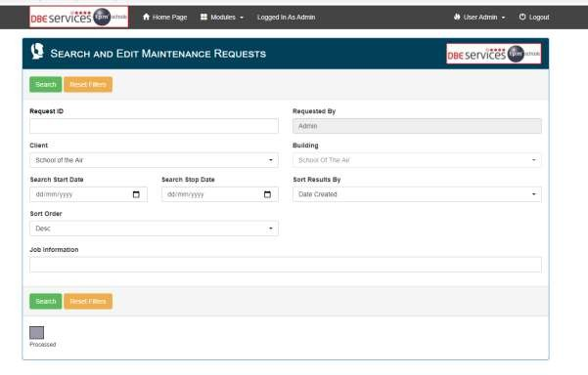
Click on ‘Maintenance Requests’.

Can use the Start & Stop Date filters if required to look at a certain period.

To view everything that is on the system simply click on the Search button

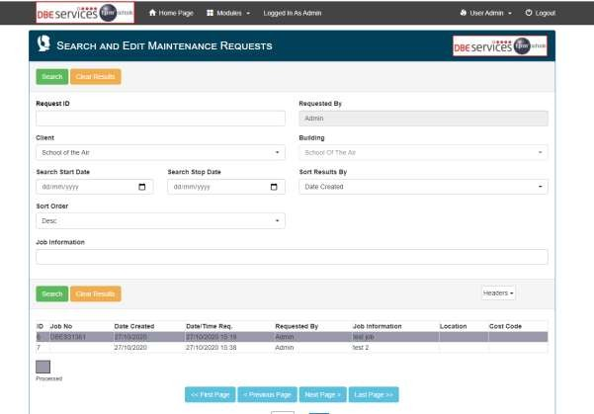
The jobs that have been requested will be seen here
If the job remains white this hasn’t been actioned at the help desk yet.

If the job has been highlighted grey this means it has been processed on the system – it will have been allocated a job number (DBES..).

Works Diary
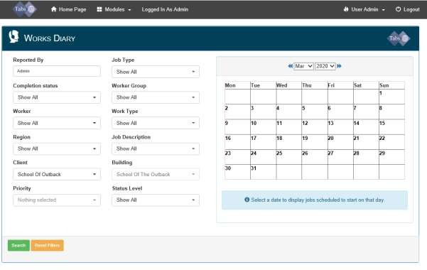
This allows the school to view all planned and reactive jobs that are due to take place each month of the year. This option also allows the school to access details on what jobs are due to take place.

Click on ‘Works Diary’.
This should automatically default to the school name.
If the login has access to multiple schools i.e. Dioceses/ MATs filter this accordingly. If you want to view all schools within that login ensure this field is blank.

You can use the Job Type section to filter on viewing either PPM Jobs (service) or Help Desk Jobs (reactive jobs).

The works diary month view allows the user to see all PPM
(planned )and Helpdesk (reactive jobs) that are being undertaken in the relevant month. By selecting the date at the top of the calendar, you can change the month which allows you to look forward or backwards in the year.

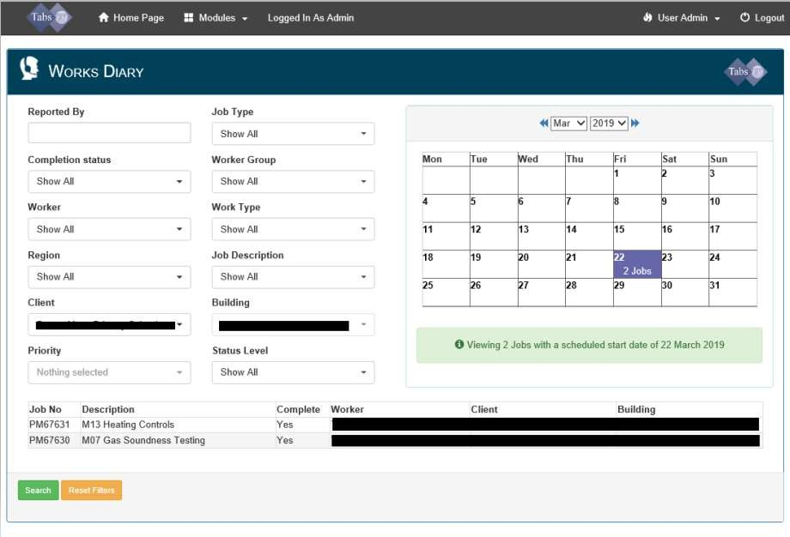
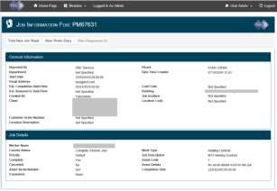

Note: PPM Jobs (Planned Maintenance/Services) there may be a number of jobs due on 1st of each month for maintenance/services – it simply means these are due to be done at some point during that particular month. Contractors will contact at the start of the month to book in a date.

Note: Helpdesk Jobs (Reactive Jobs) the date for these requests will be down as the date they have been actioned on the system (not the date they are due to be completed). When opening up the job details this will provide information on where this is up to and give the estimated completion date.
To see the specific details of jobs click on the highlighted date in which the jobs are showing, and the system will show a broken-down list at the bottom of the page.

If you click on any job within the list shown above this will open a job summary page as shown here. The general information section will show details on the date this is estimated to be completed. The job updates section will provide information and updates on this job. If needed this can be printed using the buttons at the top of the page.

Year Planner
This page allows the school to view their annual plan showing all planned (and reactive if required) maintenance dates along with any paperwork. This planner is in Calendar year rather than schools’ financial years.

Click on ‘Year Planner’.

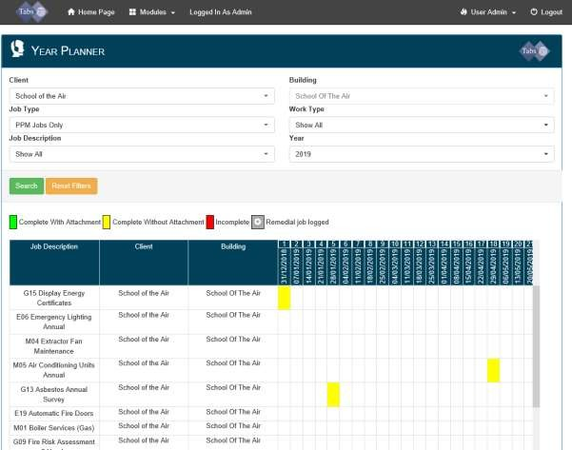
Use this to filter on viewing either PPM Jobs (services/planned maintenance) or Help Desk Jobs (reactive jobs) or both.
Upon clicking ‘Year Planner’ your bespoke annual planned maintenance programme will show on the screen. This programme will incorporate any reactive helpdesk jobs that have been logged and planned (if selected using the Job Type above) This document is live and will immediately update following on from logged, completed or cancelled services.
You are able to click on any coloured boxes shown in the year planner to show what specific services/jobs are due to be undertaken that day. The colour system shows whether a service/job is outstanding (red), has been undertaken but no paperwork has been received (yellow) or complete with paperwork (green).

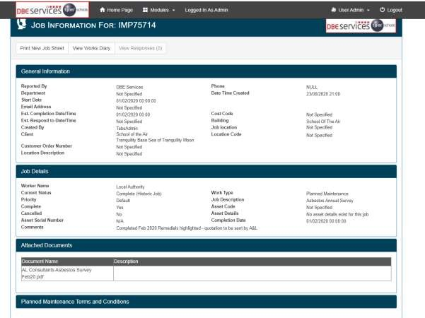
Once you click on the attachment you wish to view this should automatically download you a copy to view.
If there are any attachments these will be shown in the attached documents section. Click on the heading to expand this section and the attachments can be viewed.

If there are any recommendations made on a job these can be seen the Job Details section under comments.
Upon clicking the relevant coloured box, the following general information sheet will appear on the screen. This will provide specific details about the job.

The ‘Attached Documents’ section for PPM jobs (maintenance/services) will include any service sheets/reports relating to that particular service and any quotations following the service.
This section for Helpdesk Jobs (reactive) will include the invoices we receive from the contractor and any quotations following this. Copies of these documents will also be emailed over from the system.

Accessing Documents
To access your documents, click on Modules in the top bar, Maintenance and then click on either Works diary or Year planner. Both ways let you access your saved documents.
Works Diary – Click on the Works Diary Icon, that will take you to a view where you can filter down what you need on the left, or by using the calendar on the right.

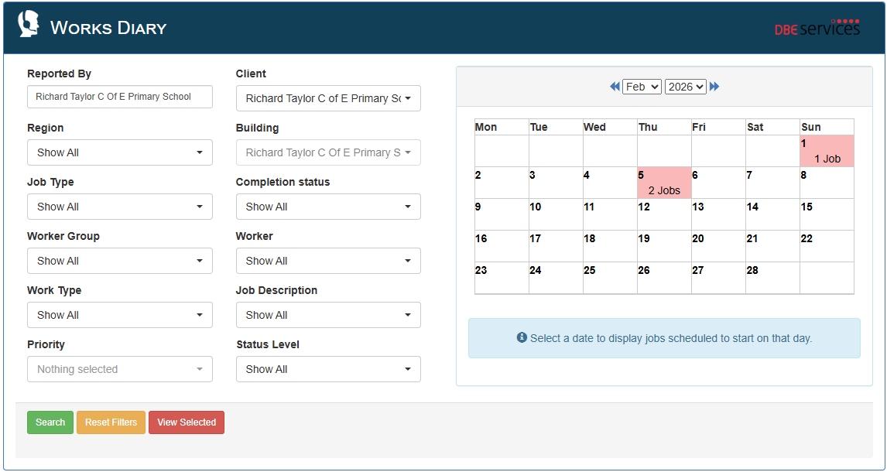
Click on the highlighted dates to see what jobs are either complete or booked for that month. Click on the highlighted dates and that will bring up a list below the diary.

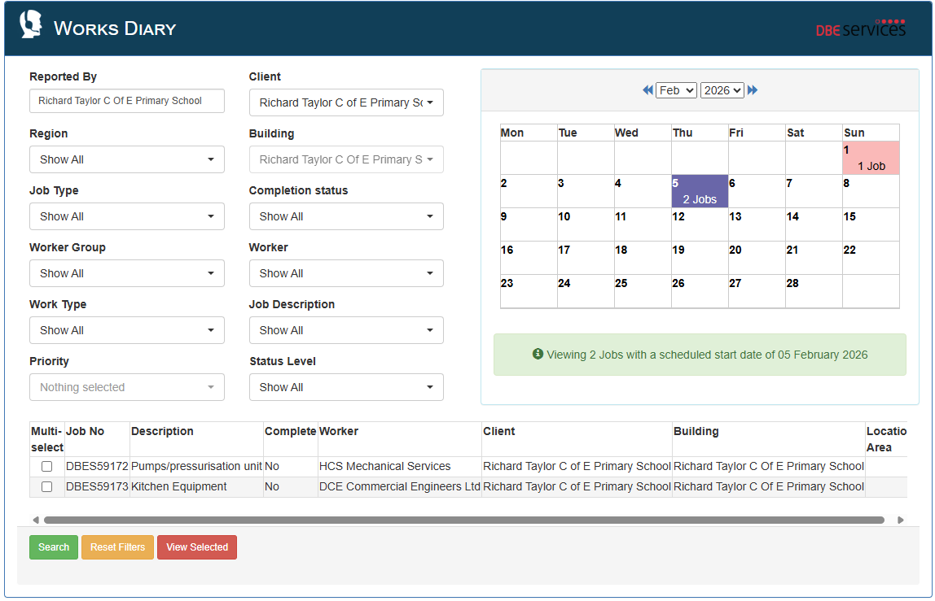

If you click on the job description, it will take you to a Job Information page where you will see all the information regarding that job.

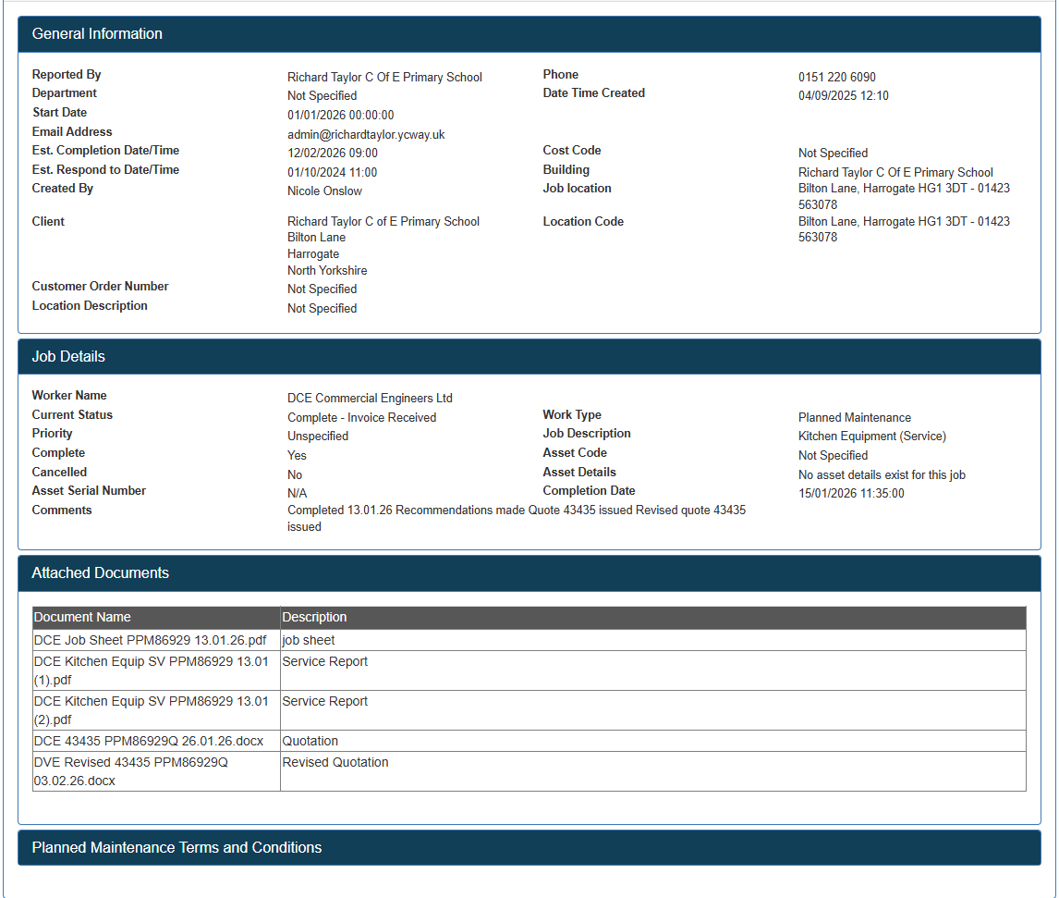

You can print off this information by using the Print new job sheet tab at the top and you can go back to the works diary by clicking on the View works diary tab at the top.
All DBES numbered jobs are Reactive jobs, and all PPM numbered jobs are Planned servicing jobs.
Below the description is an attached documents section. If you click on the document name, then this will download that document for you.

Year Planner – This works in the same way as the above. All dates and services are stated, and all green cells are completed with documents, Red isn’t complete. If you click on the green cell, then that will take you to the job information page the same as above.
You can use the filters to filter down to what you need, PPM jobs (planned servicing), Job description (What service was done) and what year you want to see.

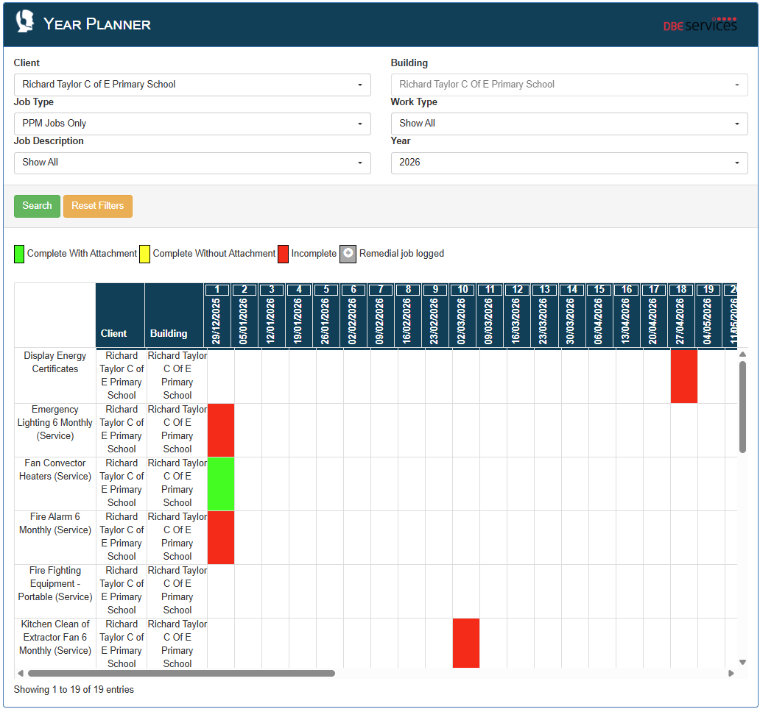

Logging off the system
To log out of the system, simply click on the Logout icon top righthand corner:
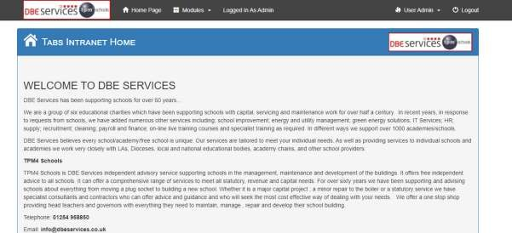
Log off.

